**TDD using Junit5 and Mockito**

Exercise 1: Setting Up JUnit

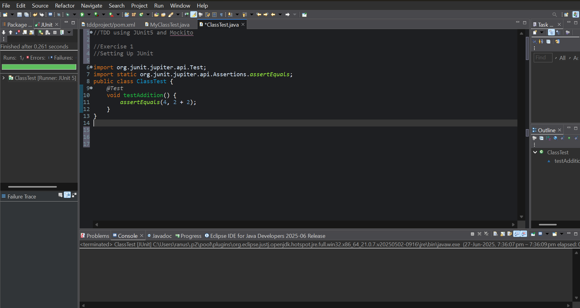

Exercise 2: Assertions in Junit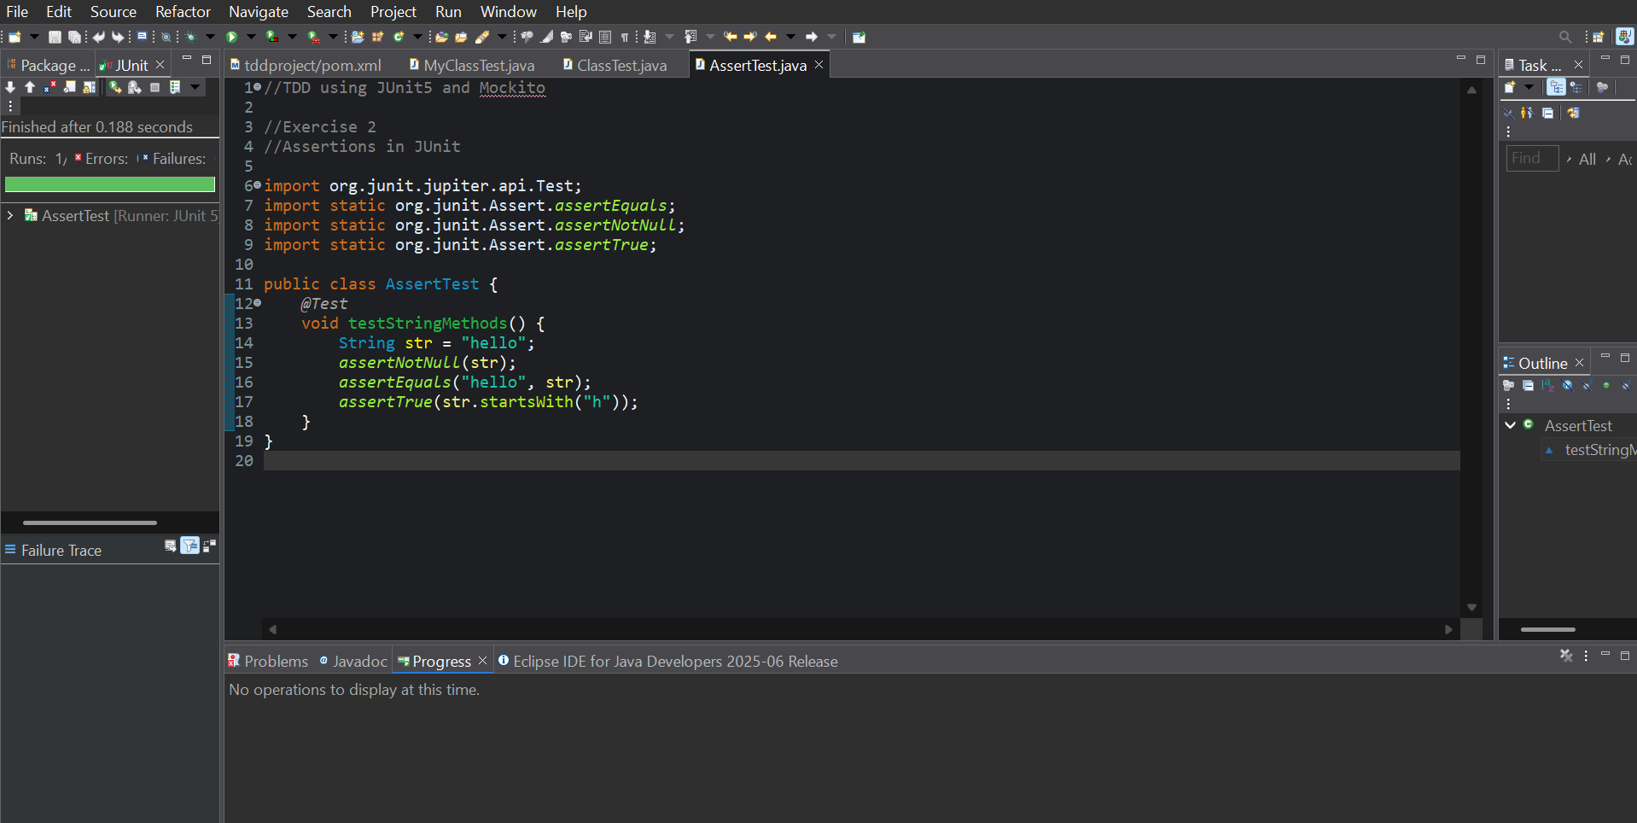

Exercise 3: AAA Pattern, Test Fixtures, Setup, and Teardown Methods

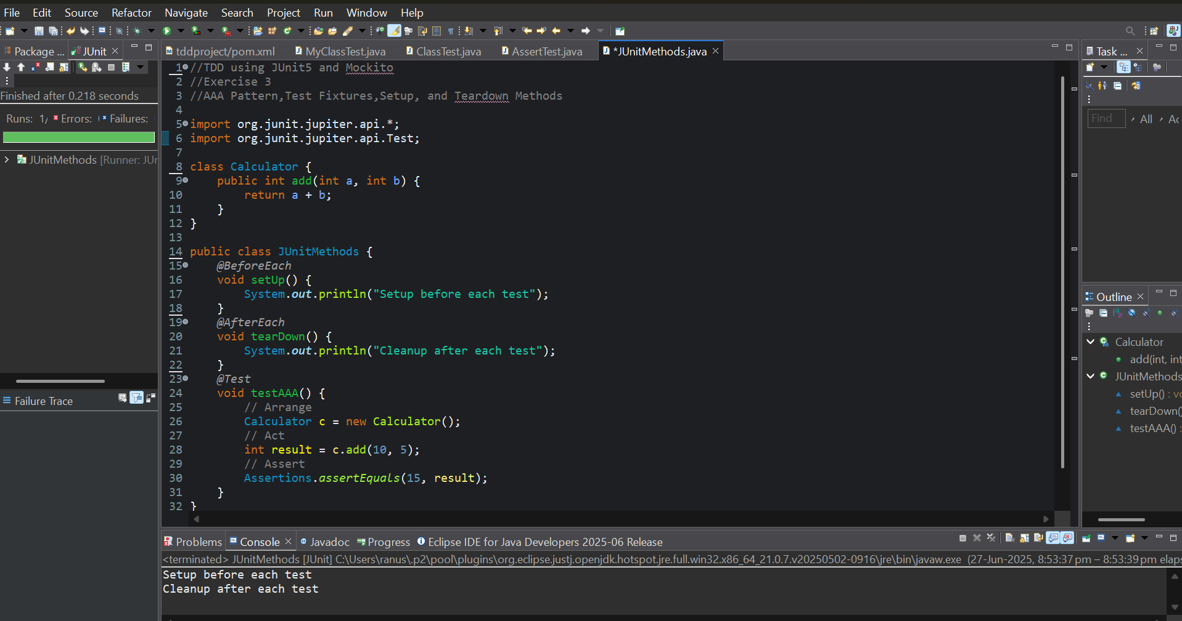

**Mockito Exercises:**

Exercise 1: Mocking and Stubbing

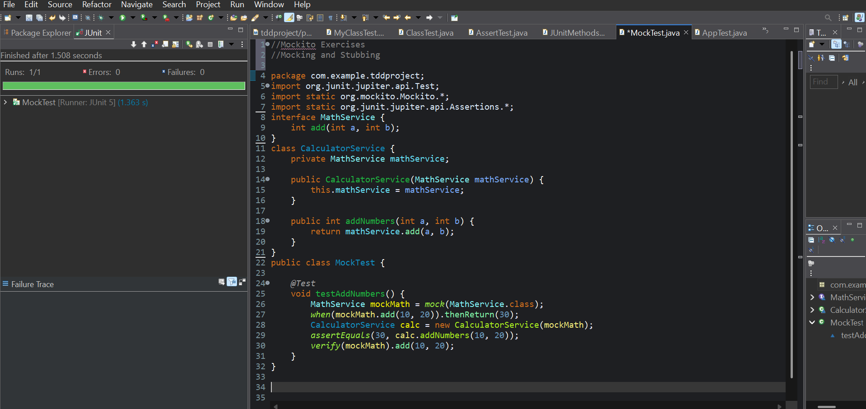

Exercise 2: Verifying Interactions

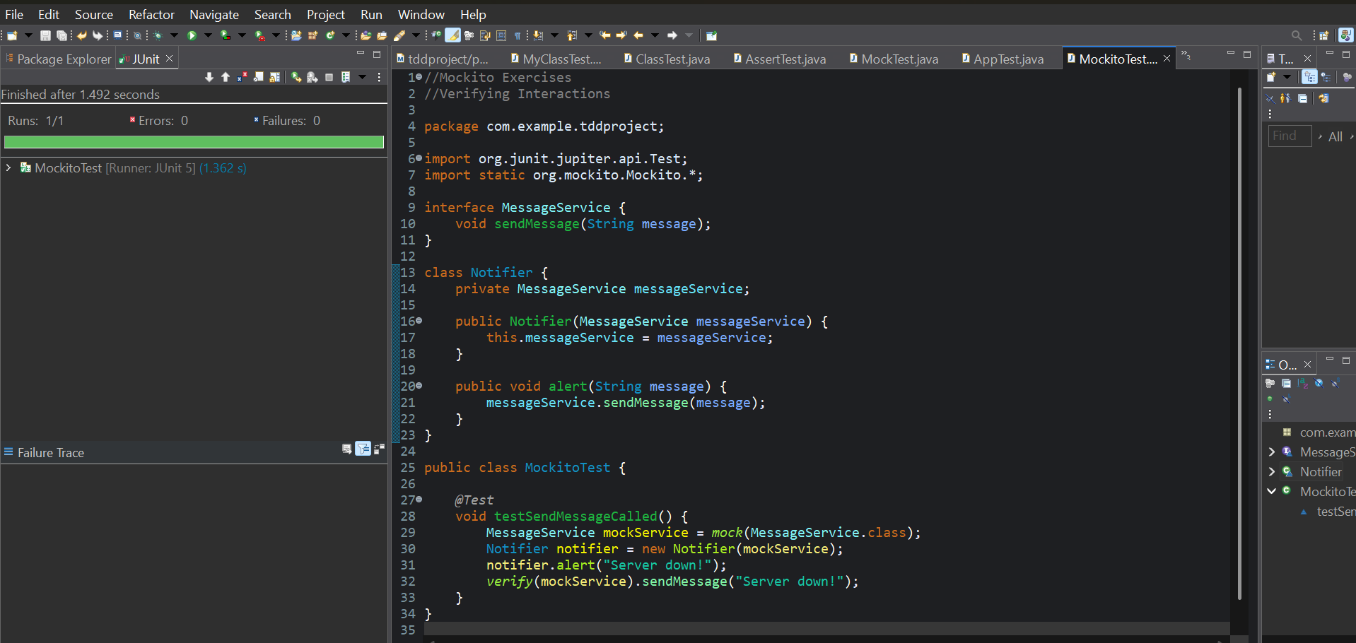

**SLF4J Logging Framework:**

Logging Error Messages and Warning Levels

